Project Planning Phase

|  |  |
| --- | --- |
| NAME | AHAMED ALI H |
| TEAM ID | PNT2022TMID37442 |
| PROJECT TITLE | IoT Based Safety Gadget for Child Safety Monitoring & Notification |

USN 1: As a user I need to enroll the cloud registration

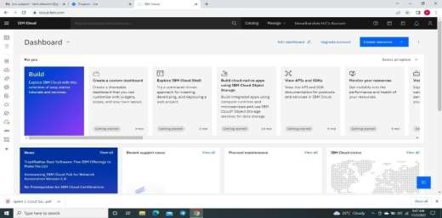

USN 2: As a user, I will create IBM cloud account

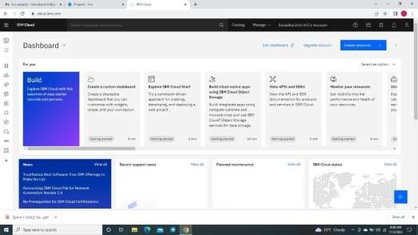

USN 3: After creating cloud account launch IBM Watson IOT platform by accessing cloud account

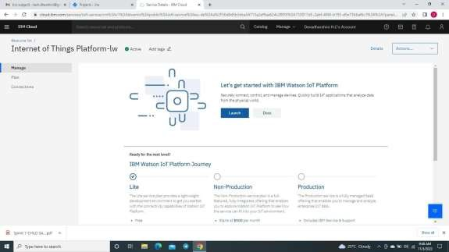

USN 4: Create the node in IBM Watson platform

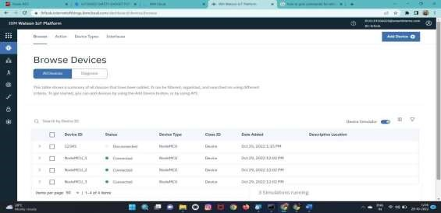

USN 5: After Creating node get device Type and id

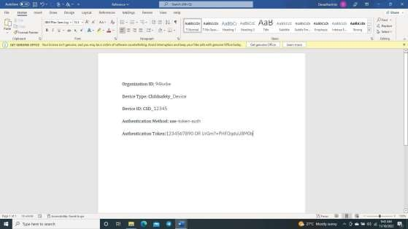

USN 6: Simulate the node created

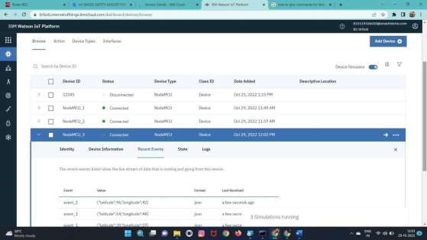

BURNDOWN CHART:

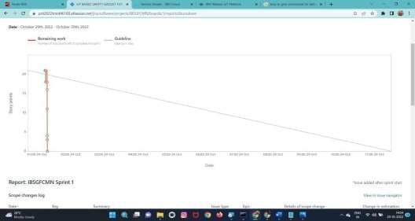

Velocity Chart:

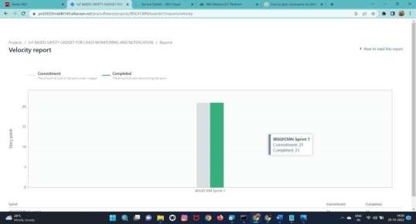

ROADMAP:

